1. Begin by opening the LexisNexis CD Client

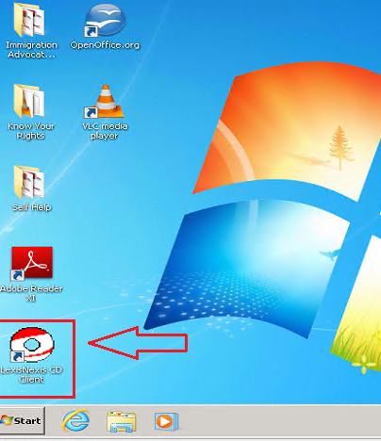

1. Select the “Immigration Prison Library” from the content selector screen

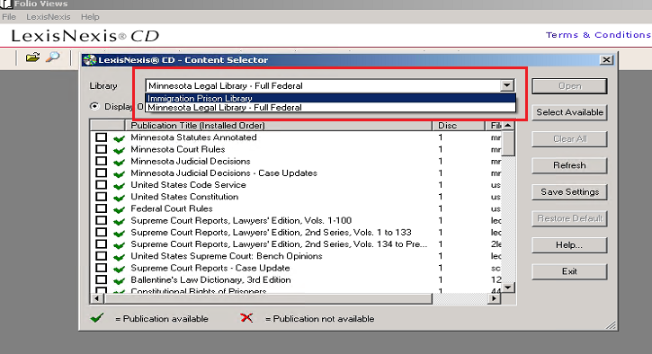

1. Scroll down until you find “Immigration Official Forms” Check the box or double click and then click the “Open” button in the upper right corner.

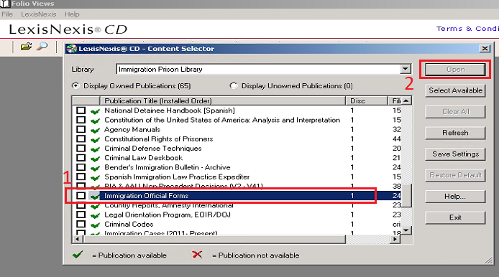

1. In the screen that opens up, scroll down until you find the form you need.